**Integrated Rice Advisory System: An Innovative Framework for Climate Smart Rice Farming in Bangladesh**

**Abstract**

This study provides a scientific and integrated approach to a demand-driven framework for generating and disseminating weather forecast-based advisory services (WFBAS) for climate smart rice farming in Bangladesh. Implementing WFBAS under the Integrated Rice Advisory System (IRAS) platform can considerably reduce detrimental impact of climate and weather extreme events on rice. The WFBAS technology under IRAS is a framework for applying relevant meteorological information and assisting farmers in making the most resource-effective and environmentally responsible usage possible with the goal of increasing agricultural output in terms of quality as well as quantity. On-farm strategic and tactical decisions is made and disseminated through IRAS platform to the stakeholders. The process would be as follows: *Firstly*, medium-range weather prediction would be prepared by the Bangladesh Meteorological Department and then sent to scientists of the agricultural department. Agricultural scientists from several disciplines would, secondly, employ climate and weather estimations to build agricultural advisories that would accelerate any advantageous effects of ideal weather conditions and eliminate negative ones of opposites. *Thirdly*, weather-sensitive agricultural activities like planting and transplanting crops, fertilizer application, infectious disease and pest control, interrelated irrigation timing, on time crop harvest, etc. will be performed according to the generated advisories. IRAS platform would be used as a one-stop solution for visualization of location-specific weather forecasts, advisory generation, and dissemination to extension officials and farmers. *Finally*, to guide policymakers to lessen negative consequences of an unfavorable weather pattern, IRAS can send information to them before start of crop seasons. 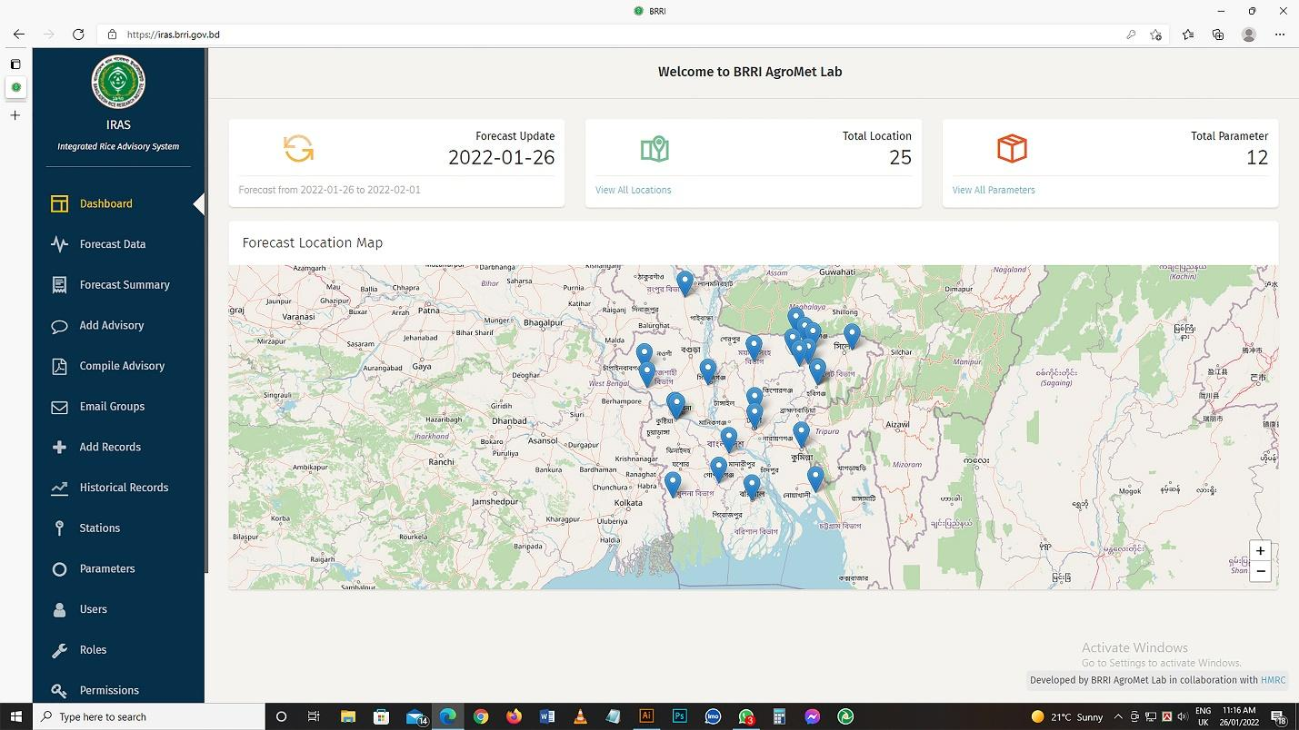

**Keywords:** Rice advisory, weather, and climate risks, constraints, opportunities.

1. **Introduction**

Bangladesh is set to move from being the least developed country to becoming a developing one, facing climate change challenges (Rahman et al., 2022). Weather and climate are major drivers of a country's agricultural economy that affect yield, efficient crop farming, the value of farmland, and agricultural system productivity (Singh, 2019; Paparrizos et al., 2020; Hossain et al., 2020; Aziz et al., 2022a). Climate and weather patterns support socially, economically, and ecologically sustainable agricultural operations (Bal et al., 2021). It is also economically important for all levels (farmers, researchers, extension workers, and planners at different levels) of decision-making and at all stages (pre-sowing to post-harvest to market) of the agricultural system (Bind, 2021). Managing weather and climatic hazards in agriculture has become a key challenge due to climate change (Rahman et al., 2023; Aziz et al., 2023b). Agriculture is influenced by local climate fluctuations rather than global climate trends (Rahman et al., 2023). Both direct and indirect effects of climate change shape the agricultural productivity. It manifests through altered rainfall patterns, the occurrence of prolonged droughts, episodes of flooding, and the shifting distribution of pests and diseases across various regions (Gitz et al., 2016). A crucial hindrance to ensuring better crop management in Bangladesh is weather and climate variability and extreme events. Unprecedented climate extremes are created by the alarming increase in the frequency, intensities, spatial range, duration, and pattern of weather and climate extremes (Zhai et al., 2018). Moreover, heat waves, droughts, flash floods, excessive rainfall, and other natural disasters, for example, are becoming more common. Increased crop productivity is threatened by adverse weather conditions, which is one of the major causes of crop losses and food insecurity (Islam et al., 2022). Weather forecast-based advisory service impacts climatic parameters to minimize crop production losses (Singh, 2019; Rahman et al., 2021). Agricultural advisory services are important in empowering small farmers to tackle emerging challenges in adopting environmentally sustainable production techniques (Birner et al., 2009). Advisories based on weather forecasts integrate crop-related and meteorological data to offer farmers actionable guidance (Gopalakrishnan, 2020). Hence, efficient crop management is one of the major components of increasing crop yield.

Since it accounts for 90% of all food grain output in Bangladesh, rice is a vital crop for the country's cereal crop industry (Rahman et al., 2020). Rice is the primary food consumed by about 100% of the nation's population (HIES, 2021). Significant non-food uses include livestock, fisheries, and industry. As a result, one of the cornerstones to achieving food security is enough rice production. Like the majority of other rice-growing nations worldwide, Bangladesh really views "food security" and "rice security" as being synonymous (Brolley, 2015). One of the biggest challenges facing a nation with a growing population, less arable land, and frequent long- and short-term climate threats is ensuring food security (FAO, 2017a). According to the World Bank, GFDRR (2011), there is a 3.1% annual decline in Bangladesh's agricultural GDP due to climate change. Farmers' ability to make functional and designed agricultural management decisions is severely hampered by increased climatic instability, which has the potential to significantly impede rice production (Rahman et al., 2020).

Similarly, elevated temperatures beyond certain thresholds have been found to curtail the duration of rice crops, hinder effective flowering, induce spikelet sterility, decreased yield and lower quality rice grains (Shahid et al., 2018; Hasanuzzaman et al., 2013; Wassmann et al., 2009). Therefore, various weather-smart rice cultivation strategies must be employed to account for climate variability and the effects of unfavorable weather conditions. Bangladesh's national agricultural strategy has already emphasized improving early warning systems to forecast meteorological factors and provide farmers with actionable advice (NAP, 2018). The mid-term (2-3 years) action plan under the thematic area of increasing agricultural production suggested creating agricultural weather forecasting systems that are timely, easily accessible, and as accurate as possible and innovation of various adverse environmental tolerant crop production technologies, including disease and insect resistant, drought, salinity, waterlogging, heat, to cope with the risks posed by climate change.

The analysis and application of weather and climate data to increase agricultural output is known as weather forecast-based advice services (Ahmad, 2017). It has been demonstrated that weather forecast-based advice services, which leverage weather and climate data to increase agricultural productivity, are an effective means of promoting climate-resilient agriculture (Chakraborty, 2018). On the other hand, although daily location-specific weather/climatic services are critical for optimal food cultivation in the Bengal Delta, they are still limited among farming communities. As a result, smallholder decision-making requires location-specific, skilled, and tailored weather/climatic information services (DAE, 2018; Ahmed et al., 2019). The importance lies in ensuring that agricultural advisory services promptly address the diverse information needs of farmers while being driven by their demands. Additionally, it is crucial to improve the efficiency and long-term viability of these services. Moreover, equal access to agricultural advisory services must be ensured for marginalized groups, such as female farmers, the impoverished, and other disadvantaged communities (Birner et al., 2009). So, our objective is to develop a demand-driven framework named Integrated Rice Advisory System (IRAS) for weather forecast-based advisory services (WFBAS) that includes an appropriate weather forecast, advisory generation, and distribution mechanism, all contained within a farmer-friendly platform.

In Bangladesh, a nation highly vulnerable to climate change and unfavorable weather occurrences, rice is the most essential crop for guaranteeing food security. Therefore, a weather-smart rice crop management system must be established to address this issue. This system should be established under a sustainable weather forecast based crop management framework, which is already under practice in different countries (Thakur & Uphoff, 2017; Sheinkman et al., 2015; Wani & Sawargaonkar, 2018), however it does not exist in Bangladesh. The objective of this study is to bridge this gap by delivering a framework for weather-smart rice crop management that is sustainable, outlining its efficient operations, and highlighting its effects on Bangladesh's rice industry.

The rest of the paper is structured as follows. Section 2 mentions the methodology of forming the IRAS framework for rice management. The results and discussion has been illustrated in the Section 3 that cleared the activities and working process of IRAS. Section 4 discusses the impacts of IRAS with a brief review of literature, and Section 5 concludes with suggesting way forward action plan.

1. **Materials and Method**

**Selection of the Study Area**

The study area for this research was selected based on the relevance of agricultural conditions and climate resilience challenges faced by crop farmers in Bangladesh. The regions chosen for this study are primarily located in areas vulnerable to climate change impacts, including variations in rainfall patterns, rising temperatures, and the frequency of extreme weather events such as floods and droughts. These areas were also selected based on their reliance on integrated crop management systems for sustainable farming practices. The geographical focus includes both coastal and inland regions, where smallholder farmers are most affected by climate-related challenges.

**Description of the Study Area**

Bangladesh is located in South Asia and is one of the most climate-vulnerable countries in the world. The country is characterized by a predominantly agrarian economy, with the majority of the rural population depending on agriculture for their livelihoods. Major crops in the region include rice, jute, sugarcane, and a variety of vegetables, all of which are sensitive to climatic fluctuations. The study area spans several districts across the country, focusing particularly on areas where agricultural productivity is significantly impacted by unpredictable weather patterns. The selected districts exhibit a range of weather conditions, including flooding in the monsoon season, drought during the dry season, and extreme temperatures. These districts are representative of both irrigated and rain-fed agricultural systems, providing a diverse perspective on the integration of climate-smart agricultural practices.

**Selection of Stakeholders**

The study involved multiple stakeholders to ensure a comprehensive and multi-disciplinary approach to the development of the IRAS framework. The key stakeholders were selected based on their roles in the agricultural value chain and their expertise in climate-smart agricultural practices. These included:

**Agricultural Extension Professionals**: These individuals are vital for implementing crop management strategies at the grassroots level. They were selected from various levels, including:

* + Deputy Directors (DDs) and Additional Deputy Directors (ADDs) from the District level, are responsible for overseeing agricultural extension activities.
  + Sub-Assistant Agriculture Officers (SAAOs), Upazila Agriculture Officers (UAOs), and Agriculture Extension Officers (AEOs) from Union and Upazila levels, who directly engage with farmers and disseminate extension services.

**Bangladesh Meteorological Department (BMD)**: Personnel from BMD provided essential meteorological data and insights on weather forecasting, which is crucial for the planning of climate-resilient crop management strategies.

**Regional Integrated Multi-Hazard Early Warning System (RIMES)**: RIMES experts participated to offer knowledge on multi-hazard early warning systems, which can assist in informing agricultural planning based on weather predictions.

**Farmers**: Smallholder farmers were directly involved in the consultations as they are the primary beneficiaries and practitioners of the integrated crop management strategies. Their input ensured that the framework developed is grounded in practical experience and aligns with local needs.

**Data Collection**

Data for this study were collected through a combination of literature review, expert consultations, and field-level discussions. The data collection process was structured as follows:

**Literature Review**: Initially, a comprehensive review of existing literature on integrated crop management, climate-smart agriculture, and crop weather-based advisory systems (WFBAS) was conducted. This review included an analysis of climate-smart agricultural practices that have been implemented in Bangladesh and other regions with similar climatic conditions.

**Consultation Meetings**: Nine consultation meetings were held with the expert stakeholders and farmers. These meetings were designed to facilitate a discussion on the applicability of climate-smart agriculture in Bangladesh, the role of meteorological data, and the challenges faced by farmers in adopting such practices. During these consultations, the following data were gathered:

* + Farmers’ knowledge of climate variability and its impact on crop yields.
  + Insights from agricultural extension professionals on existing crop management practices.
  + Recommendations from meteorologists and early warning system experts on how to integrate weather data into farming practices.

**Field Observations**: Data were also collected through field visits to observe current farming practices and to directly interact with farmers regarding their crop management techniques, challenges, and needs for climate resilience.

**Data Analysis**

The data collected were analyzed to identify patterns and insights that could inform the development of the IRAS framework. The analysis followed a multi-step approach:

**Synthesis of Literature Findings**: The knowledge gained from the literature review was synthesized to outline the climate-smart practices most applicable to Bangladesh's farming systems. This included understanding the specific challenges farmers face due to climate variability, such as water scarcity, flooding, and pest outbreaks.

**Thematic Analysis of Consultation Data**: The data from the stakeholder consultations were analyzed thematically. Key themes included:

* + The effectiveness of current crop management practices.
  + The perceived impact of weather forecasts on agricultural decision-making.
  + Barriers to adopting climate-resilient practices.

**Integration of Stakeholder Feedback**: The feedback gathered from stakeholders was used to refine the IRAS framework, ensuring that it was both feasible and relevant to local conditions. Stakeholders' perspectives were incorporated into the design of the platform, with an emphasis on ensuring its practicality for farmers.

**Development of the IRAS Platform**: Based on the findings from the consultations and literature review, the IRAS platform was developed in collaboration with the Bangladesh Meteorological Department (BMD), the Bangladesh Rice Research Institute (BRRI), and the Department of Agricultural Extension (DAE). This platform integrated weather forecasting data, research-based crop management strategies, and extension services to provide farmers with actionable advice on climate-smart crop management.

1. **Results**

A framework for generating weather forecast-based rice advisories and disseminating them to extension officials and farmers for better crop management has been presented in Fig. 2 to generate automated weather forecasts, advisories, dissemination, and application of the research outcome more quickly. It is important to develop an integrated rice advisory system named IRAS. The "Integrated Rice Advisory System (IRAS)" is a web-based platform that provides location-specific rice production management advice and services, considering the weather forecast for different rice growth stages. For local farming systems, agromet recommendations are required. Agrometeorological advisory systems that are effective require customized agricultural weather forecasts and two-way communication (Walker, 2021). This underscores the importance of developing weather-based Agromet alerts tailored to specific locations (Balasubramanian et al. 2014; Balasubramanian et al. 2016). In IRAS, we have proposed three components that would be coordinated from the same platform: meteorology, research, and extension.

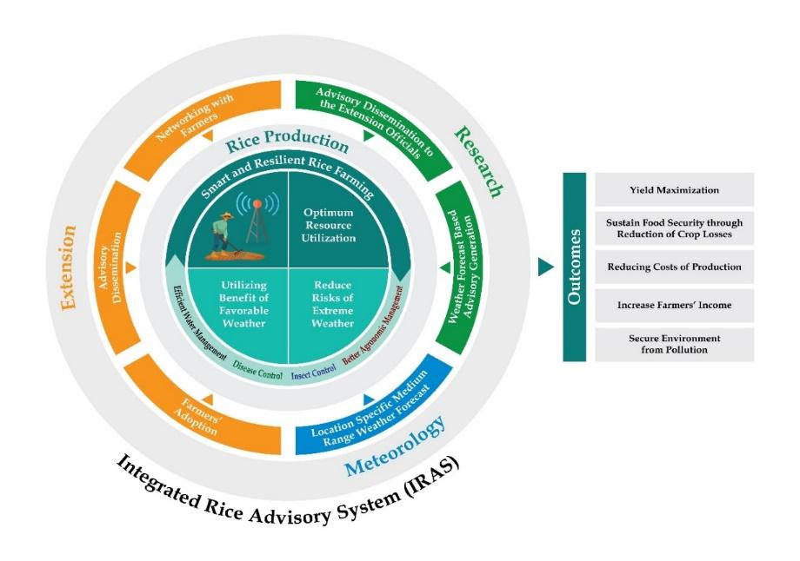

**Figure 2** A Framework for Integrated Rice Advisory System (IRAS) in Bangladesh.

*Meteorology*: The BMD would handle the meteorology portion and uses the Weather Research and Forecasting (WRF) Model at the mesoscale, which was created collaboratively by various US government institutions. Forecasts produced by the model have a lead time of three to seven days, a horizontal resolution of nine kilometers, and a vertical resolution of 38 layers (Mohapatra, 2018). The BMD has tremendously advanced weather/climate info facilities in collaboration with national and international institutions. By communicating early warnings, the BMD forecast can help manage extreme occurrences (Habib et al., 2012). Under this system, location-specific weather parameters (highest and lowest temperatures, humidity ratio, rainfall, soil moisture, wind speed, solar radiation, etc.) would be forecasted in a medium range (weekly) and automatically save and visualize the forecast results by a collaboration with Bangladesh Meteorological Department (BMD). Farmers would be benefitted from location-specific and expert climate information services (Kundu et al., 2020). While farmers know the wide-ranging influences of weather and climate on their agricultural productivity, getting precise information applicable to their activities directly from traditional weather prediction remains problematic (Stigter et al., 2013). The proposed weather forecast system resembles Nepal Agromet Advisory Services (Timilsina et al., 2019).

*Research*:A thorough weather-based farm advisory analyzes how weather parameters would affect crops and farm operations in the future and present, as well as recommendations for measures to be performed (Singh, 2019). It should ultimately give weather data and add value to it by providing advice on agricultural quality standards tailored to the forecasted weather (Gopalakrishnan, 2020). To maintain productivity, it is now essential to manage various agricultural resources as well as other supplies like water, fertilizer, insecticides, and pesticides (Ahmad et al., 2017). An expert group comprising entomologists, plant pathologists, plant physiologists, irrigation & water management specialists, soil scientists, and agronomists would be responsible for preparing advisories at different growth stages based on the information from location-specific weather forecasts for efficient crop management. The expert group considers various factors, including weather forecasts, alerts regarding severe weather events, knowledge about customary crop sowing practices in specific areas, agricultural management information such as irrigation scheduling, pesticide application for pest and disease control, nutrient application (e.g., N, P, K), and any special warnings that may arise (Bal, 2021). The weekly bulletin should be created considering the rice crop's susceptibility to insects and infections. The bulletins outline potential rice crop risk-mitigating actions (Singh, 2019). A thorough understanding of the connections between crops and weather is necessary for the successful creation of advisory bulletins (Bal et al., 2021). The DAE personnel, the Farmers' Information and Advice Center (FIAC), and farmers would get the weekly regional warnings and special bulletins in adverse weather conditions by voice and text messages. Multidisciplinary research teams should work together to develop efficient integrated systems for evaluating weather forecasts in relation to agricultural administration decisions and strategies for getting them to farmers at the appropriate time, according to Stigter et al. (2014a,b,c). In order to create beforehand and agromet advising systems that address farmers' needs and inquiries specific to their region and production systems, farmers and such teams can work together. Every Sunday, IRAS will issue advisories regarding rice crops for specific areas.

*Extension:* Agricultural extension and advisory services are defined by Anderson (2007) as "the entire collection of organizations that assist and support persons engaged in agricultural production in solving problems and gaining information, skills, and technology to improve their lives." The extension also plays a crucial role in assisting researchers in tailoring technology to farmers' agro ecological and resource circumstances. Once advisory bulletins have been created, they must be broadly distributed to farmers (Gopalakrishnan, 2020). In addition to disseminating advisory bulletins to farmers, the DAE is responsible for fostering awareness across various dimensions of technology adoption. It is crucial to ensure that farmers are genuinely convinced of the advantages of advisory services, as the information generated holds little value otherwise (Bal, 2021). Therefore, extension officials need to create a smooth network with the farmers. After that, DAE officials and FIAC would be in charge of distributing advisory bulletins to farmers in their specific regions using a variety of communication ways (Figure 3), including emails, WhatsApp groups, Facebook groups, messenger groups, mass media (radio, television, and newspapers), cellular phones (call, voice SMS and text SMS (in local languages)) and through the involvement of meetings in person, engagement with the farmers club, climate-smart school, farmers field school (FFS), field day, radium display, digital display boards, kiosks, Call Centers, Non-Government Organizations (NGOs), etc. In a proposition by Chakraborty et al. (2018), the dissemination of the bulletin is suggested to be carried out by field information facilitators, who are resource persons designated explicitly for this purpose within the target village. Feedback information was collected from both villages. Villages having a range of communication channels, such as SMS and voice messaging, meetings and training with agricultural extension agents, local information centers, farmers' groups, and village announcements over the microphone, had higher awareness of and utilization of advisory services (Venkatasubramanian, 2014). To ensure accessibility and active participation of farmers, Rahman et al. (2020) emphasize the necessity of implementing a toll-free number for the advisory service. This facilitates the provision of free assistance to farmers and allows for regular incorporation of their feedback as long as it is deemed justifiable. The call center of Agricultural Information Service (AIS) already has a toll-free number to facilitate this regard which can be used to disseminate advisory bulletins to farmers through voice SMS service. At the same time, other forms of communication, including radio, television, newspapers, and so on, can be used to improve farmer awareness. Farmers can call AIS's toll-free number for assistance and feedback anytime. Finally, extension workers will collect information and feedback on the use of technology to encourage farmers to use it. A system for providing feedback will be created to get feedback from farmers on the accuracy of predictions, the applicability of warnings and advisories, and the efficiency of distribution channels, in order to contact farmers to distribute WFBAS bulletins. To improve and expand distribution in order to swiftly reach more farmers, new projects are being developed. Developing agromet (weather forecast-based) advisory services requires collaborative efforts involving farmers, researchers, and extension workers to devise resolutions collectively (Walker et al., 2010).

The role of weather prediction, advisory generation, and dissemination services for weather or climate-resilient rice production and web-based IRAS is depicted in Fig. 3 and Fig. 4, respectively. Communication and advisory services could benefit from using ICT technologies and social media platforms (Kumar, 2021). Farmers and rural people in developing nations now have considerably better access to information thanks to the falling costs of information and communication technologies (ICTs). Farmers can use ICTs to access a range of extension services, but it takes time to build demand-driven services (Anderson, 2008). This is the first time in Bangladesh that an efficient use of ICT has been used to provide weather forecast-based advisories to farmers' doorsteps named IRAS. The farmer would benefit significantly from the scaling up. If the role of the weather forecast-based Advisory Service is properly conceived and effectively executed, agricultural development challenges may be eliminated through extension services. More specifically, by the successful implementation of the proposed strategies explained here towards adopting the IRAS in the rice crop management system, farmers would ensure the judicious use of inputs through better agronomic practice, efficient water management, and control of the infestation of insects and diseases, can be possible to use the benefit of suitable weather, and minimize the danger of severe climate events. Consequently, there would be an increase in grain production, the environment would be protected from pollution by reducing the amount of fertilizer, pesticides, and herbicides left behind, groundwater pressure would be relieved by effective water management, and farmers would ultimately benefit financially from increased yield and decreased production costs. Weather forecast-based advisories are such adaptation strategies that have already shown considerable progress (Singh, 2019).

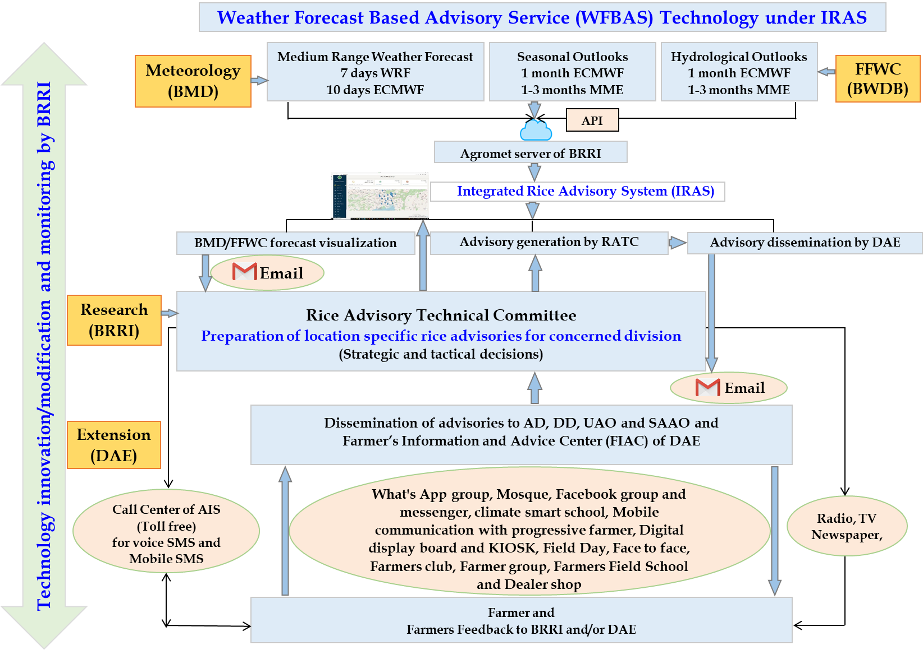

**Figure 3.** A theoretical framework of WFBAS under IRAS

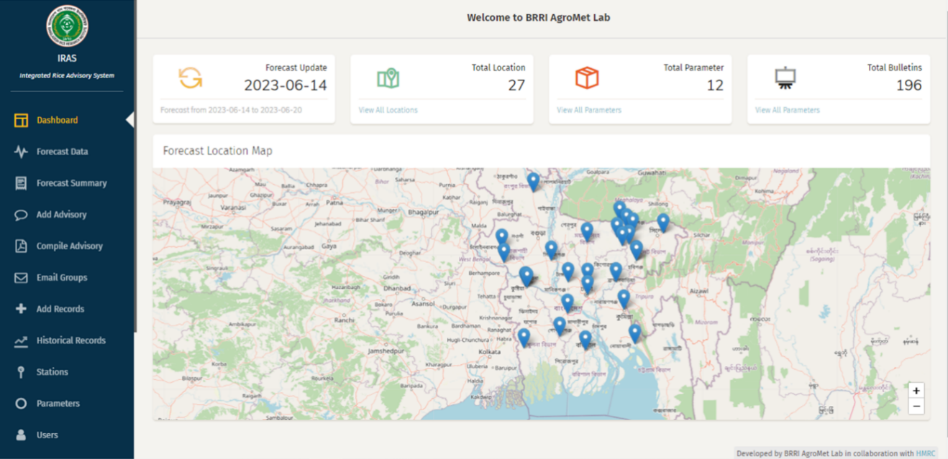

**Figure 4.** Dashboard of web-based Integrated Rice Advisory System (IRAS)

India is already practicing climate smart crop management through a weather forecast based agromet advisory service through Agromet Decision Support System (Agromet-DSS). This system is developed and managed by the Indian Meteorological Department (IMD). Under Agromet-DSS there is an expert committee for advisory generation consisting of university teachers/researchers, research institutes, and extension officials. For efficient climate-smart crop management, the expert committee creates advisories based on crop-weather relationships and weather forecast data. The generated advisories disseminated automatically through different extension channels to the farmers. The Agromet-DSS has a web-based app (*Meghdoot*) for automatic advisory dissemination. The Agromet-DSS also collects feedback from the farmers and extension channels to take actions for further modification to make the system more efficient and effective (Singh et al., 2023).

1. **Discussion**

The weather forecast-based advisory services (WFBAS) for climate-smart crop management has a greater impact in the case of yield and overall economic return. Camacho and Conover (2010) discovered that having access to weather data helped to lower crop losses. Studies by Ramachandrappa et al. (2010, 2013; 2018) also showed comparable outcomes. Other research (Das et al. (2019), Chakraborty et al. (2018), and Maini and Lathore (2010) revealed a 6.7–15% increase in rice yield in farmers' fields when the advising service was contrasted with the conventional method. Singh et al. (2022) showed that farmers who received Agrometeorological Advisory Services (AAS) could increase their wheat and cotton yield by 6.25% and 5%, respectively. According to research conducted by India's National Center for Medium-Range Weather Forecasting (NCMRWF), the AAS increases agricultural production yield by 8–20%. The yield was higher for the AAS farmer, 8.7% in the case of wheat, and 0.82% for paddy (Gupta et al., 2021). A similar result was obtained by Ray et al. (2017) for direct-seeded rice in Keonjhar district of Odisha. Ananta Vashisth et al. (2013) found that the implementation of weather-based crop management practices, such as timely land preparation and sowing, selecting appropriate seed rates and varieties, weeding, maintaining soil moisture, applying pesticides, irrigation, and harvesting, increased farmers' profits from the adoption of AAS. The introduction of agromet advisory bulletins, which were based on the NCMRWF's medium-range weather forecast, increased yield by 13–15 quintals ha-1 in rice and 10 quintals ha-1 in mango and cashew nut crops in Maharashtra, India, according to Chaudhari et al. (2010).

According to Everingham et al. (2002), Gadgil et al. (2002), and Ingram et al. (2002), farmers place a higher importance on weather and climate forecasts when they can affect their decisions about important farm management operations. Therefore, it becomes vital to align with farmers' expectations, understand their demands, and produce forecasts within acceptable spatial and temporal ranges, as underlined by Hammer et al. (2001), Hansen (2002), and Nicholls (2000).

These efforts ultimately enhance the reliability of the forecasts and contribute to the improved adoption of weather-based advisories, as discussed by Stone and Meinke (2006).The ultimate impact of weather forecast-based crop management is observed by its economic benefits, generated by incorporating the costs of production and overall return. Dewi and Whitbread (2017) showed that weather forecasting-based advisory services can lower production costs results in the case of Senegal and Indonesia, respectively. By using weather forecast-based management, farmers can reduce input costs by as much as 6% in wheat, 9.6% in carrots, 2.4% in maize, and 1.8–7% in rice, according to research by Khan et al. (2018) and Ananta Vashisth et al. (2013). Compared to non-AAS farmers, advice services decreased cultivation costs by 4.81% for AAS farmers, according to Dupdal et al. (2020). Gupta et al. (2021) also stated that advisory services reduced cost by 2.5% for rice compared to traditional farmers. According to research conducted by India’s National Center for Medium-Range Weather Forecasting (NCMRWF), the Agromet Advisory Service (AAS) aids to reduce agricultural yield costs by 5–12 %. Das et al. (2019), Chakraborty et al. (2018), Maini and Lathore (2010) stated that AAS reduces the costs of cultivation by 2–5%. Adoption of weather forecast-based crop management techniques, such as timely weeding, maintaining soil moisture, applying pesticides, irrigation, harvesting, and land preparation and sowing, as well as the adoption of recommended seed rates and suitable varieties, contributed to the increased adoption of AAS and helped maximize cropping system yield (Ananta Vashisth et al., 2013).According to Singh et al. (2022), the implementation of an advising service resulted in increased net profits for cotton and wheat by 17% and 21%, respectively, for timely and late seeded crops. Researchers Rajegowda et al. (2008) found that in the Eastern dry zone of Karnataka, farmers who implemented the AAS saw an average economic gain of 31.4%, 24.7%, 16.2%, and 20.6% in the fields of finger millet, red gramme, field beans, and tomatoes, respectively. In comparison to non-AAS farmers, Dupdal et al. (2020) found that AAS farmers' income increased by 19–34% and 12–33%, respectively. Farmers can enhance net profit by 0.9%, 3%, 14%, and 4–11%, according to Khan et al. (2018) and Ananta Vashisth et al. (2013). Das et al. (2019), Chakraborty et al. (2018), and Maini and Lathore (2010) showed that AAS generates a 19.74% higher net return than non-AAS. Chattopadhyay (2018) conveyed that by adopting AAS, farmers enhanced returns by 10–25%. According to research conducted by India’s National Center for Medium-Range Weather Forecasting (NCMRWF), the Agromet Advisory Service (AAS) increased gross return by 8–20%, and net return by 16–20%. In comparison to non-AAS farmers, Dupdal et al. (2020) found that AAS farmers' income increased by 19–34% and 12–33%, respectively. Tarchiana et al. (2021) explored the provision of accessible, trustworthy, and appropriate agrometeorological services in Burkina Faso, which have contributed to a 40% reduction in production costs and a 41% gain in income for farmers.

Rahman et al. (2021) observed that while the overall impact would raise farmers' profits by 25%, implementing WFBAS in rice cultivation would lower cultivation costs by 12% in Bangladesh. According to their estimates, if just 5% of rice farmers use WFBAS for crop management, 0.17 million tons more rice could be produced. Rahman et al. (2023) demonstrated in a multi-location experimental test that, in comparison to the conventional usual management practice, rice farmers in Bangladesh would enhance or even maintain their yields while using 16% less fertilizer, 23% less irrigation water, 52% less herbicides, 40% less insecticides and 26% less fungicides when they followed WFBAS. Therefore, the weather forecast-based crop management imposes potentiality to reduce costs of cultivation, secure the environment by ensuring judicial and effective utilization of inputs, and increase yield and overall return. The proposed framework would be an effective way of sustaining rice productivity in Bangladesh towards achieving the sustainable development goal and feeding the ever-increasing population of Bangladesh.

1. **Conclusion**

In this article, an overview of research methodologies on rice advice services is provided, along with a conceptual framework. Additionally, the framework can serve as a valuable tool for policymakers in identifying potential options. The major goal of the WFBAS via the IRAS framework is to gather and organize data on soil, crops, weather, and other factors to help farmers make management decisions. The Department of Agricultural Extension (DAE) and the National Agricultural Research Service (NARS) in Bangladesh are actively engaged in research and extension endeavors aimed at modifying the socioeconomic standing of the farming community. According to our framework, we propose that BMD will collaborate with IRAS by producing weather forecasts. BRRI oversees generating rice advisories for various growth stages in different locations considering the crop-weather interactions, and DAE will disseminate that weather forecast-based rice advisories to farmers. Agro-meteorological applications for practical agriculture in dynamically changing environments have profited from this in terms of the development and implementation of operational instruments for controlling weather-related uncertainties in agriculture. The WFBAS should be maintained by: (a) an agro meteorological database, (b) crop situations, (c) real-time weather conditions, research findings on crop-weather relationships, and (d) a competent staff in interdisciplinary resources to make it a more effective and continuous process. Weather and climate data empower policymakers, institutions, and communities to make informed decisions that reduce risks, unlock opportunities, optimize the utilization of limited resources, and enhance agricultural output. However, for the benefit of the region's farming community, this must be spread throughout the region. Finally, target 2.4 of the sustainable development goals (SDGs) would be achieved with the successful and wider implementation of WFBAS in the rice management system, maintaining rice production and farmer income. This paper mentioned to use WFBAS under IRAS for climate smart rice crop management in the administrative divisional level of Bangladesh. However, the proposed climate smart crop management system can be suitable for other administrative levels (country, region, district, Upazila, block, etc.). Although the proposed platform focused on rice crop management, it would be equally helpful for all other crop management.

**References**

Ahmad, L., Habib Kanth, R., Parvaze, S., & Sheraz Mahdi, S. (2017). Agro Meteorological Advisory Service. In *Experimental Agrometeorology: A Practical Manual* (pp. 123-125). Springer, Cham.

Ahmad, L., Kanth, R. H., Parvaze, S., & Mahdi, S. S. (2017). *Experimental agrometeorology: a practical manual* (pp. 83-87). Springer International Publishing.

Ahmed, M. M., Bhuiyan, M. S. H., Momin, M. A., Haque, M. M., & Kabir, A. M. (2019). Final report on agro-meteorological training needs assessment. *Agro-Meteorologica l Information System Development Project, Bangladesh Department of Agricultural Extension, Dhaka*.

Anderson, J. R. (2008). Agricultural advisory services. Background Paper for the World Development Report. [http://siteresources.worldbank.org/INTWDR2008/Resources/27950871191427986785/Anderson_ AdvisoryServices.pdf](http://siteresources.worldbank.org/INTWDR2008/Resources/27950871191427986785/Anderson_%20AdvisoryServices.pdf)

Aziz, M. A., N. M. F., Rahman, Rahman, M. C., Nihad, S. A. I., Ahmed, R., ... & Kabir, M. S. (2023b). Present and future precipitation scenario of Bangladesh. *Bangladesh Rice Research Institute.* SRL printing press, Dhaka, Bangladesh. ISBN 978-984-35-3975-5.

Aziz, M. A., Shohan, H. U. S., Rahman, N. M. F., Rahman, M. C., Nihad, S. A. I., Hassan, S. Q., ... & Rukshanara, Z. (2023). Projection of future precipitation in Bangladesh at Kharif-II season using geospatial techniques. *Earth Systems and Environment*, *7*(1), 255-266.

Bal, S. K., Rao, K. V., Chandran, M. S., Sasmal, S. U. B. O. D. H., & Singh, V. K. (2021). Weather forecast, agriculture contingency plan and agromet–advisory services for climate resilient agriculture. *Ind J Agron*, *66*.

Balasubramanian, T. N., Jagannathan, R., Maragatham, N., Sathyamoorthi, K., & Nagarajan, R. (2014). Generation of weather windows to develop agro advisories for Tamil Nadu under automated weather forecast system. *Journal of Agrometeorology*, *16*(1), 60.

Balasubramanian, T. N., Jagannathan, R., Maragatham, N., Sathyamoorthi, K., Nagarajan, R., Vanangamudi, M., ... & Hameed, J. A. (2016). Designing agromet advisories for selected weather windows under automated weather based advisory system in Tamil Nadu–A case study. *Journal of Agrometeorology*, *18*(1), 34-40.

Birner, R., Davis, K., Pender, J., Nkonya, E., Anandajayasekeram, P., Ekboir, J., ... & Cohen, M. (2009). From best practice to best fit: a framework for designing and analyzing pluralistic agricultural advisory services worldwide. *Journal of agricultural education and extension*, *15*(4), 341-355.

Camacho, A., & Conover, E. (2010). The impact of receiving price and climate information in the agricultural sector. *Documento CEDE*, (2010-40).

Chakraborty, A. J., Banerjee, S., Mukherjee, A., Bairagya, M. D., & Ghosh, S. (2018). Climate Change and Weather Based Agro Meteorological Advisory Service: an Analysis from Farmers’ Perspectives. *Italian Journal of Agrometeorology*, *23*(3), 5-14.

Chakraborty, A. J., Banerjee, S., Mukherjee, A., Bairagya, M. D., & Ghosh, S. (2018). Climate Change and Weather based Agrometeorological Advisory Service: An Analysis from Farmers' Perspectives. *Italian Journal of Agrometeorology*, *23*(3), 5-14.

Zagade, M. V., Chaudhari, J. N., Bhagat, S. B., & Chavan, S. A. (2011). Assessment of Weather Based Agromet Advisories in High Rainfall Zone of South Konkan in Maharashtra. *Journal of Agriculture Research and Technology*, *36*(3), 474.

DAE 2018. Baseline Survey Report to Assess User Satisfaction of Agro-Meteorological Advisories and Products under the Agro-Meteorological Information Systems Development Project. In: (DAE), D. O. A. E. (ed.). Dhaka, Bangladesh Department of Agricultural Extension (DAE).

Das, H. (2019). Assessment of economic profitability of weather based agro advisory services on rice. *International Journal of Agriculture Sci., ISSN*, 0975-3710.

Dewi, E. R., & Whitbread, A. M. (2017). Use of climate forecast information to manage lowland rice-based cropping systems in Jakenan, Central Java, Indonesia. *Asian Journal of Agricultural Research*, *11*(3), 66-77.

Dupdal, R., Dhakar, R., RAO, C. R., Samuel, J., Raju, B. M. K., Kumar, P. V., & Rao, V. U. M. (2020). Farmers’ perception and economic impact assessment of agromet advisory services in rainfed regions of Karnataka and Andhra Pradesh. *Journal of Agrometeorology*, *22*(3), 258-265.

Dupdal, R., Manjunatha, B. L., Dhakar, R., & Patil, S. L. (2020). Perception and economic impact of agromet advisory services: A case study of Thrissur AICRPAM centre of Kerala state. *Indian Journal of Extension Education*, *56*(3), 10-16.

Everingham, Y. L., Muchow, R. C., Stone, R. C., Inman-Bamber, N. G., Singels, A., & Bezuidenhout, C. N. (2002). Enhanced risk management and decision-making capability across the sugarcane industry value chain based on seasonal climate forecasts. *Agricultural Systems*, *74*(3), 459-477.

Gadgil, S., Rao, P. S., & Rao, K. N. (2002). Use of climate information for farm-level decision making: rainfed groundnut in southern India. *Agricultural Systems*, *74*(3), 431-457.

Gitz, V., Meybeck, A., Lipper, L., Young, C. D., & Braatz, S. (2016). Climate change and food security: risks and responses. *Food and Agriculture Organization of the United Nations (FAO) Report*, 110, 2-4.

Gopalakrishnan, T., & Subramanian, K. (2020). Agrometeorological advisory Services in India: an assessment. *Centre for Science and Environment, New Delhi, India*, *258*.

GUPTA, S., KUMAR, A., SHAHI, U., & and GANESH PRASAD, A. S. Economic impact assessment of the Agrometeorological Advisory Service of Western Uttar-Pradesh. In *PROCEEDINGS OF VIRTUAL NATIONAL CONFERENCE ON STRATEGIC REORIENTATION FOR CLIMATE SMART AGRICULTURE (V-AGMET 2021) Volume 3* (p. 164).

Habib, A., Shahidullah, M., & Ahmed, D. (2012). The Bangladesh cyclone preparedness program. A vital component of the nation's multi-hazard early warning system. In *Institutional Partnerships in Multi-Hazard Early Warning Systems* (pp. 29-62). Springer, Berlin, Heidelberg.

Hammer, G. L., Hansen, J. W., Phillips, J. G., Mjelde, J. W., Hill, H., Love, A., & Potgieter, A. (2001). Advances in application of climate prediction in agriculture. *Agricultural systems*, *70*(2-3), 515-553.

Hansen, J. W. (2002). Applying seasonal climate prediction to agricultural production. *Agricultural Systems*, *74*(3), 305-307.

Hasanuzzaman, M., Nahar, K., Alam, M., Roychowdhury, R., & Fujita, M. (2013). Physiological, biochemical, and molecular mechanisms of heat stress tolerance in plants. *International journal of molecular sciences*, *14*(5), 9643-9684.

Hossain, M. S., Arshad, M., Qian, L., Kächele, H., Khan, I., Islam, M. D. I., & Mahboob, M. G. (2020). Climate change impacts on farmland value in Bangladesh. *Ecological indicators*, *112*, 106181.

<https://www.slideshare.net/NaveenBind/role-of-agrometeteorology-advisory-services-in-agriculture>

Ingram, K. T., Roncoli, M. C., & Kirshen, P. H. (2002). Opportunities and constraints for farmers of West Africa to use seasonal precipitation forecasts with Burkina Faso as a case study. *Agricultural systems*, *74*(3), 331-349.

Khan, N., Kumar, A., Singh, C. B., Dubey, V., & Kumar, N. (2018). Weather Based Agro-Met Advisory to Enhance the Production and Income of the Farmers under Changing Climate Scenario of Central Plain Zone of Uttar Pradesh, India. *Int. J. Curr. Microbiol. App. Sci*, *7*(11), 221-224.

Kumar, U., Werners, S. E., Paparrizos, S., Datta, D. K., & Ludwig, F. (2021). Co-producing climate information services with smallholder farmers in the Lower Bengal Delta: How forecast visualization and communication support farmers' decision-making. *Climate Risk Management*, *33*, 100346.

Kundu, S., Kabir, M. E., Morgan, E. A., Davey, P., & Hossain, M. (2020). Building Coastal Agricultural Resilience in Bangladesh: A Systematic Review of Progress, Gaps and Implications. *Climate*, *8*(9), 98.

M. Mohapatra. 2018. 'Contributions of IMD (supported by NCMRWF & INCOIS) as global centre'.

Maini, P., & Rathore, L. S. (2011). Economic impact assessment of the Agrometeorological Advisory Service of India. *Current science*, 1296-1310.

Nicholls, N. (2000). Opportunities to improve the use of seasonal climate forecasts. *Applications of seasonal climate forecasting in agricultural and natural ecosystems*, 309-327.

Paparrizos, S., Smolenaars, W., Gbangou, T., Slobbe, E. V., & Ludwig, F. (2020). Verification of weather and seasonal forecast information concerning the peri-urban farmers' needs in the lower ganges delta in bangladesh. *Atmosphere*, *11*(10), 1041.

Rahman, M C, V Pede, J Balie, I M Pabuayon, J M Yorobe and S Mohanty. 2020. Assessing the market power of millers and wholesalers in the Bangladesh rice sector. *Journal of Agribusiness in Developing and Emerging Economies*. DOI: 10.1108/ JADEE-04-2018-0053.

Rahman, M. C., Pede, V. O., & Balié, J. (2022). Welfare impact of asymmetric price transmission on rice consumers in Bangladesh. Review of Development Economics, 26(3), 1600-1617.

Rahman, M. C., Rahaman, M. S., Biswas, J. C., Rahman, N. M. F., Islam, M. A., Sarkar, M. A. R., ... & Maniruzzaman, M. (2023). Climate change and risk scenario in Bangladesh. *Asia-Pacific Journal of Regional Science,* 7(2), 381-404.

Rahman, N. M. F., Rahman, M. C., Baten, M. A., Hossain, M. I., Hassan, S. M. Q., Ahmed, R., ... & Kabir, M. S. (2021). Weather forecast based rice advisory services in Bangladesh. Bangladesh Rice Journal, 25(1), 51-74.

Rajegowda, M. B., Janardhanagowda, N. A., Jagadeesha, N., & Ravindrababu, B. T. (2008). Influence of agromet advisory services on economic impact of crops. *J. Agrometeorol*, *10*, 215-218.

Ramachandrappa, B. K., Mariraju, H., Reddy, P. C., & Ashokkumar, H. P. (2010). Impact of operational research project for dryland agriculture. *Indian Journal of Dryland Agricultural Research and Development*, *25*(1), 92-98.

Ramachandrappa, B. K., Shankar, M. A., Dhanapal, G. N., Sathish, A., Jagadeesh, B. N., Indrakaumar, N., ... & Maruthi Sankar, G. R. Ch. Srinivasa Rao and Murukanappa. 2013. *Four Decades of Dryland Agricultural Research for Alfisols of Southern Karnataka*.

Ramachandrappa, B. K., Thimmegowda, M. N., Krishnamurthy, R., Babu, P. N., Savitha, M. S., Srinivasarao, C., ... & Chary, G. R. (2018). Usefulness and impact of agromet advisory services in eastern dry zone of Karnataka. *Indian Journal of Dryland Agricultural Research and Development*, *33*(1), 32-36.

Ray, M., Patro, H., Biswasi, S., Dash, S. R., & Dash, A. C. (2017). Economic assessment of weather based agromet advisories in Keonjhar district, Odisha. *Vayu Mandal*, *43*(1), 38-48.

Shahid, M., Nayak, A. K., Tripathi, R., Katara, J. L., Bihari, P., Lal, B., & Gautam, P. (2018). Boron application improves yield of rice cultivars under high temperature stress during vegetative and reproductive stages. *International journal of biometeorology*, *62*(8), 1375-1387.

Singh, K. K., Ghosh, K., Bhan, S. C., Singh, P., Vishnoi, L., Balasubramanian, R., ... & Singh, R. (2023). Decision support system for digitally climate informed services to farmers in India. *Journal of Agrometeorology*, *25*(2), 205-214.

Singh, M., Ghanghas, B. S., Sharma, V., & Sharma, B. C. (2019). Minimize weather risk in agricultural planning and management through agromet advisory services in rural areas. *Transformation of Indian agriculture through innovative technologies. Daya Publishing House, Delhi, India*, 11-21.

Singh, R., Pal, R. K., Gill, K. K., Mishra, S. K., & Kaur, A. (2022). Validation of medium range weather forecasts and its economic impact on cotton-wheat cropping system in South-Western Punjab. *MAUSAM*, *73*(4), 915-928.

Stigter, C. J., & Winarto, Y. T. (2013). Science Field Shops in Indonesia: A start of improved agricultural extension that fits a rural response to climate change. *Journal of Agricultural Science and Applications*, *2*(2), 112-123.

Stigter, K., Walker, S., and Das, H. (2014c). Meeting farmers' needs for agrometeorological services: a review with case studies Part III: Context 2, the future. *Ital. J. Agrometeorol.* 2104, 45–52.

Stigter, K., Walker, S., Das, H., Dominguez-Hurtado, I. M., and Nanja, D. (2014a). Meeting farmers' needs for agrometeorological services: a review with case studies Part I: Introduction and history. *Ital. J. Agrometeorol.* 1/2014, 59–65.

Stigter, K., Walker, S., Das, H., Huda, S., and Haasbroek, P. D. (2014b). Meeting farmers' needs for agrometeorological services: a review with case studies Part II: Context 1, the existing situation. Ital. J. Agrometeorol. 2/2014, 51–60.

Stone, R. C., & Meinke, H. (2006). Weather, climate, and farmers: an overview. *Meteorological Applications*, *13*(S1), 7-20.

Tarchiani, V., Coulibaly, H., Baki, G., Sia, C., Burrone, S., Nikiema, P. M., ... & Camacho, J. (2021). Access, uptake, use and impacts of agrometeorological services in sahelian rural areas: the case of burkina faso. *Agronomy*, *11*(12), 2431.

Timilsina, A. P., Shrestha, A., Gautam, A. K., Gaire, A., Malla, G., Paudel, B. P., & Bhandari, H. L. (2019). A practice of agro-met advisory service in Nepal. *Journal of Bioscience and Agriculture Research*, 21(02), 1778-1785.

Vashisth, A., Singh, R., Das, D. K., & Baloda, R. (2013). Weather based agromet advisories for enhancing the production and income of the farmers under changing climate scenario. *International Journal of Agriculture and Food Science Technology*, *4*(9), 847-850.

Venkatasubramanian K, Tall A, Hansen J, Aggarwal P. 2014. Assessment of India's integrated agrometeorological advisory service from a farmer perspective. CCAFS Working Paper no. 54. Copenhagen, Denmark: CGIAR Research Program on Climate Change, Agriculture and Food Security (CCAFS).

Walker, S. (2021). Development of Tailored Early Warning Agromet Advisories for Farmers. *Frontiers in Climate*, 116.

Walker, S., & Stigter, K. (2010). Designing and selecting early warning strategies and increasing their efficiencies: multiple cropping. In *Applied Agrometeorology* (pp. 485-490). Berlin, Heidelberg: Springer Berlin Heidelberg.

Wassmann, R., Jagadish, S. V. K., Heuer, S., Ismail, A., Redona, E., Serraj, R.,& Sumfleth, K. (2009). Climate change affecting rice production: the physiological and agronomic basis for possible adaptation strategies. *Advances in agronomy*, *101*, 59-122.

Zhai, P., Pörtner, H. O., Roberts, D., Skea, J., Shukla, P. R., Pirani, A., ... & Waterfield, T. (2018). Global warming of 1.5◦ C. *an IPCC Special Report on the impacts of global warming of*, *1*.